**Homework 9: Implement graph algorithms with GridGraph**

This shows How to run and the gathered results:



…

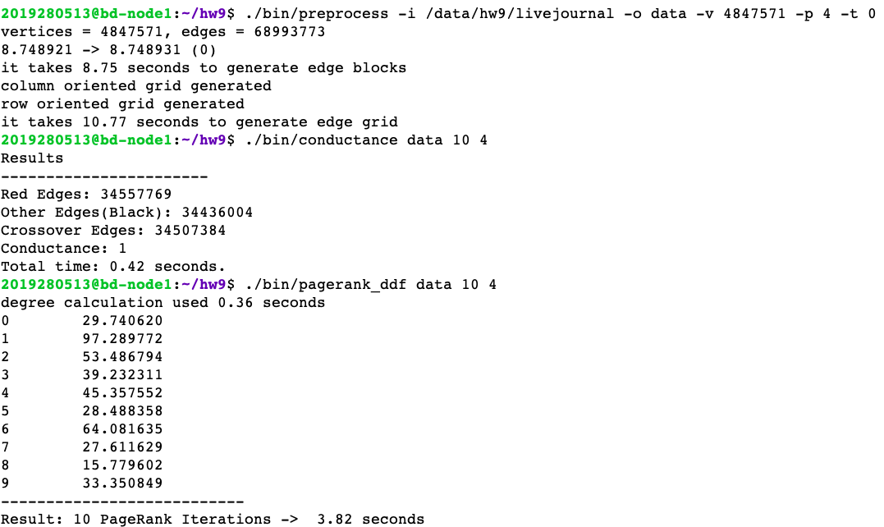

In my assignment I have chosen to implement Delta PageRank and Conductance . The given “hw9 additional material” was really helpful as a reference to build these 2 algorithms.

**Conductance**

For the conductance I simply followed the formula and given in the file and the Wikipedia explanation was a good help too. For the random walks, with a long history in the usage of the term "conductance" I have used the %2 operator to randomize the edges to find black or red edges.

After that I have applied this formula below to gather the conductance:



**Conductance Results:**

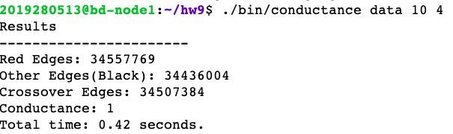

**Delta PageRank**

For the Delta PageRank since it was really similar to normal PageRank it wasn’t hard to implement I have strictly just followed the “hw9 additional material” file.

It only updates the vertices which PageRank value has changed by

more than some delta fraction as stated in the given file (in the x-stream code, the variable is called propagation threshold) .Just followed the formula and got the results below.

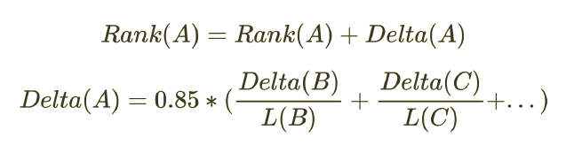

**Delta PageRank Results:**

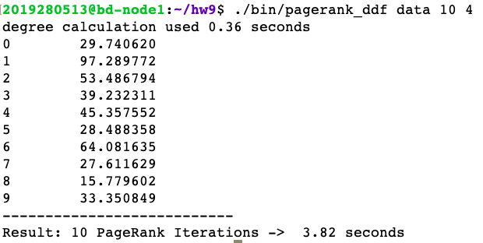

**References:**

<https://en.wikipedia.org/wiki/Conductance_(graph)>